|  |
| --- |
| Field Coordination Support Section - FCSS  **UNITED NATIONS DISASTER ASSESSMENT COORDINATION TEAM (UNDAC)**  **END OF MISSION REPORT – Bangladesh / Sundarbans Oil Spill – 17 December 2014 – 2 January 2015** |
|  |

Mission duration

The UNDAC mission consisting of four experts arrived in country on 17 December, 2014. By 20 December the full team, supported by additional national and international experts, was assembled in Dhaka. On 22 December the team left Dhaka for the Sundarbans region, where it spent six days conducting assessments around the oil spill site. The team returned to Dhaka on 28 December; presenting the final findings to the Government and the press on 31 December 2014.

Composition of the team

The mission consisted of 25 core team members, of which 14 were nationals of Bangladesh and 11 were international staff. The team was additionally supported by a number of experts and representatives of Government, NGOs, academia and international organizations. Four members of the team were mobilized through the UNDAC system (see below). The full team is given in Annex 1.

|  |  |  |  |
| --- | --- | --- | --- |
| Team member | Country | Organization | Mission dates |
| Emilia Wahlstrom | Finland | OCHA / UNEP | 17.12.2014 – 02.01.2015 |
| Per-Anders Berthlin | Sweden | UNDAC | 17.12.2014 – 02.01.2015 |
| Haruka Ezaki | Japan | UNDAC | 17.12.2014 – 04.01.2015 |
| Stephane Le Floch (Associate expert) | France | CEDRE (deployed through European Union Civil Protection mechanism) | 18.12.2014 – 04.01.2015 |

The team was divided into six sub-teams, shown in the organizational chart below.

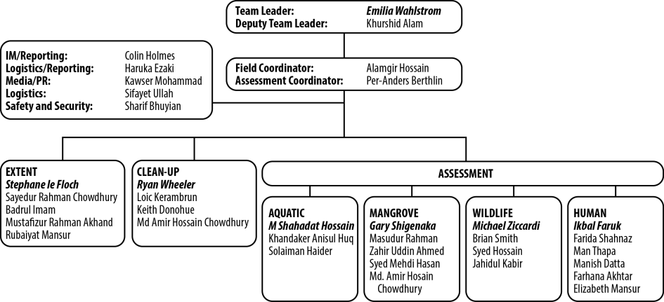

Requesting entity

On 15 December, the Economic Relations Division (ERD) of the Ministry of Finance of the Government of Bangladesh (GoB) submitted a request to the United Nations Development Programme (UNDP) to provide technical assistance in response to the Sundarbans oil spill to: 1) assess the oil spill containment and clean-up needs, and 2) conduct an assessment and draft an action plan for recommended mitigation measures.

Why did the situation require UNDAC to be requested?

A tanker carrying a reported 357,664 litres of heavy fuel oil collided on 9 December, 2014, at around 5:00 am local time, with another vessel and partly sank in the Shela River situated within the Sundarbans mangrove region in Bangladesh. A major breach was made in the hull causing oil to spill into the river and adjacent side channels and creeks. By the afternoon of the next day the oil had spread at least 20 km upstream to Mongla and at least 20 km downstream to Horintana. The accident caused widespread concern for the Sundarbans ecosystem, which is the world’s largest mangrove forest and has been a Ramsar site since 1992 and part of which is a UNESCO World Heritage site since 1997. Due to its richness of biological diversity the entire Sundarbans (6,017 square kilometres) is under some form of state protection. Furthermore, millions of Bangladeshis depend upon the Sundarbans for food, livelihoods and shelter. The oil spill took place within the Chandpai Wildlife Sanctuary, which was recently established to protect important dolphin habitat. Concern about the potential impacts of the oil to the ecosystem and the communities that depend on it for their livelihoods, led the Government of Bangladesh on 15 December 2014 to request the United Nations Development Programme (UNDP) provide technical assistance in assessing the impacts and supporting the response. The location of the spill is shown in Figure 1.

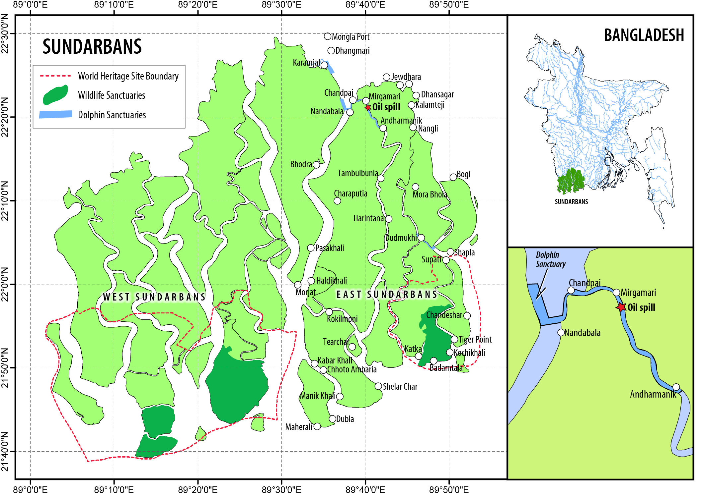

***Figure 1.*** *Location of oil tanker accident site*

Terms of reference of the UNDAC mission

The objective of the Joint UN / GoB Sundarbans Oil Spill Response mission was to:

1. Strengthen GoB’s effort in containing oil spillage and clean-up

2. Provide support to GoB in assessing the situation and developing an action plan for a phased response and recovery.

Since most of the containment and clean-up work - with the exception of oil waste management - had been completed by the time of the field assessment, the majority of the team was involved in the second objective namely the assessment of the situation and the development of appropriate recommendations.

The overall mission approach was guided carefully by the principles of neutrality and impartiality, as well as by the ‘do no harm’ principle to ensure that response and assessment efforts do no additional damage to the sensitive ecosystem of the Sundarban. The assessment built on local expertise and capacity, with international experts working in conjunction with national and local experts and MoEF Department of Environment (DOE) and Forest Department (FD) officials. This collaboration greatly contributed to the success of the assessment and is expected to facilitate the implementation of Team’s recommendations. This joint Bangladesh-international effort contributed to information-exchange between experts and developed local capacities on oil spill response and assessments.

The mission used a combination of literature review, on-site land- and vessel-based direct observations, interviews, sampling and surveys to develop findings and develop recommendations. The mission worked in close coordination with representatives of national authorities, academia, NGOs and UN agencies, as well as communities.

Coordination issues

As the mission was of specific and technical nature, coordination was primarily undertaken through existing UNDP / Government structures. The Deputy Team Leader was located in Dhaka and acted as the primary focal point between the Government and the team. He was also the primary focal point for coordination with various international and bilateral agencies located in the country; ensuring inclusion of bilateral experts and support into the Joint UN/GoB Assessment Team.

Exit strategy/Handover

The report and assessment were prepared on the basis of information and observations possible within the mission timeframe. The mission focused on the situation at the scene of the accident, as observed between 22 and 28 December 2014. The mission developed immediate, mid-term and long-term recommendations to address the oil spill, reduce the potential impacts to humans and the environment, and prevent future spills (Annex 2). These recommendations were presented to the MoEF on 31 December 2014. MoEF is currently developing an action plan to implement the provided recommendations provided by the mission as well as by other assessments. It was recommended that the action plan be developed in consultation with all affected stakeholders – including all relevant Ministries – specifying responsible parties, timelines and necessary resources to monitor the impacts of the oil spill and if necessary, carry out restoration activities. Support from the international community, UN agencies and civil society can be requested for the development and implementation of the plan.

The Mission additionally recommended the action plan be independently evaluated at six months and two years to assess the follow up of the action plan. This periodic evaluation should be conducted in consultation with key Mission participants, including GoB, relevant academia, civil society and UN representatives, as appropriate. This will support accountability and sustainability in addition to providing recognition to stakeholders for what has been accomplished after the report, and for assessing if modifications are needed or possibly new recommendations added.

Exit strategy and sustainable handover was greatly facilitated by the fact that national authorities, academia and civil society were included in the team and had a key role in the development of the recommendations. This way it could be ensured that the proposed actions were feasible and adapted to local realities and capacities. The MoEF and the Forest Department are already conducting a number of proposed monitoring and assessment activities.

The role of UNDP and international development agencies in the assessment and liaison work was also imperative in ensuring that the recommendations and follow-up actions were included into longer-term projects and programmes. After the completion of the mission, assessment and recovery activities were continued with the support of the United Kingdom – who mobilized an expert from the International Tanker Owners Pollution Federation to follow up on the mission’s recommendations on the disposal of oiled debris. Additionally, a grant from the UNESCO Rapid Response Facility was given to MoEF to carry on response and recovery activities in the affected communities. UNDP and the Wildlife Conservation Society were also able to incorporate part of the recommendations into projects planned for the Sundarbans region. Finally, involved academic institutions are planning to continue environmental monitoring in the area.

Main impact and added value of the mission

The incident in the Shela River represents a serious oil spill accident in a wildlife sanctuary and World Heritage and Ramsar site treasured for its unique biodiversity. Approximately 358,000 litres of heavy fuel oil were spilled from the damaged tanker. The mission focus lay in strengthening GoB’s efforts in containing the spillage and clean-up, and to provide support in assessing the situation and developing an action plan through the provision of appropriate recommendations.

When it comes to spillage containment and clean-up, the operations are completed with the exception of the management of oiled waste. The BPC reported that 68,200 litres had been purchased, based on payment records to local communities – representing approximately 19% of the oil spilled. Remaining oil on shoreline and vegetation, apart from nipa palm leaves, does not warrant further clean-up action after consideration of net environmental benefits. The removal of oiled debris, the management of response generated waste, and the assessment of a final disposal option is ongoing and should continue until complete. Efforts are underway to identify and relocate oil impacted debris and vegetation to centralized dewatering cribs. The MoEF is evaluating potential disposal options and is working with partner Ministries, affected communities and local authority representatives to determine a suitable location.

With respect to the response, the lack of a formal oil spill contingency plan; which among other things designates an appropriate competent authority to oversee the response as well as the limited experience and response infrastructure, made response and recovery efforts challenging. Despite these limitations, the concerted efforts of the FD, such as the provision of nets to limit the spread of oil into tributaries, and the coordination of oiled vegetation collection, reduced the impacts.

For a few community members, the incentive scheme helped to compensate for the loss of income from a loss of fishing days, destroyed fishing gear and unsalable contaminated catch. Notwithstanding the rapid community efforts to remove oil from the river system the lack of training, appropriate equipment and experience resulted in unintended negative impacts to the environment and the local community. The delay in supply of personal protective equipment caused, at least temporarily, immediate health impacts among the community responders, who reported short-term difficulties in breathing, headaches and vomiting.

On-site observations, satellite and aerial imagery as well as bottom surveys imply that most of the oil released has either been washed out along the Shela and Pashur rivers or contained by shoreline vegetation. Timely tidal variations and the decision to ban tanker traffic in the Shela River immediately after the accident occurred, minimized the penetration of oil into the mangrove ecosystem from the waterways. Even so, the main shorelines 40 km up- and downstream of the incident site, excluding creeks, show varying degrees of oil residue contained in the vegetation.

With respect to the effects of the oil on the mangrove environment, no visible impact on the mangrove forest floor due to the accident has been observed. No oil or oiled debris was found to have moved beyond the shoreline adjacent to the rivers and canals in the broader forest habitat. Had the oil and oiled debris spread, they would have presented immense logistical challenges for both detection and remedial action and significantly increased the severity of spill effects. Minor mangrove seedling impacts were noted, but new growth was already observed on affected plants. Because of this, immediate and short-term impacts of the oil spill to mangroves may be limited.

Initial acute impacts to wildlife from this spill, based on observable mortality and visible oiling on and/or behavioural changes to live animals, appear to be limited in scope. Geographically these effects are focused no farther south than Andharmanik. This finding should not be interpreted as “no effect”, as there may be subclinical or sub-apparent impacts present that were not observable during this rapid assessment. Additionally, there may have been significant non-observable acute impacts to wildlife populations, as it was difficult to fully assess the region (especially terrestrial environments) and because the rapid assessment activities occurred almost two weeks following the oil release.

When it comes to the fate of the residual oil in the environment, it is too early to make any comprehensive judgments vis-a-vis potential impacts. Data recorded immediately after the spill shows no decline in fish and invertebrate species but about half of interviewees in local communities reported a decline in catch.

When it comes to human and socio-economic impacts, the assessment revealed that the impact on livelihoods was intense during the first two weeks due to refraining from fishing and collecting forest resources by local community members. While many fisherfolk lost their nets and tools for income-generation, other community members suffered the loss of domestic livestock (i.e. ducks due to oiling). A very small percentage of community members received a short-term economic benefit from the oil recovery scheme. The long-term effects on livelihoods, food security and health cannot be assessed in the allocated timeline of this rapid assessment. The oiling of nipa palm could temporarily be disruptive to communities engaging in palm leaf harvesting, and additionally cause health concerns and waste disposal issues.

While the analysis of the rapid assessment is encouraging in terms of immediate impact, it does not reduce or eliminate the need for monitoring of mangrove ecosystem conditions and health in the future. Mangrove systems offer unique and important opportunities for assessment of longer-term or chronic effects from the oil spill. The work conducted by the Joint Mission in terms of oil extent assessment, mangrove, wildlife and fisheries monitoring, provides a solid platform on which to construct a more robust surveillance and monitoring program.

In conclusion, the oil spill accident within a wildlife sanctuary represents a serious wake-up call. While a number of factors limited the impact of the spill, the shipping of oil through a valued and biodiverse environment presents a substantial risk to both the environment and the communities that depend on it for their livelihoods. Appropriate safeguards and mitigation measures need to be put in place to prevent and prepare for oil spills in the Sundarbans and throughout Bangladesh for all significant marine routes. Caution and prudence dictate that the situation be carefully monitored for change to discern any longer-term or chronic effects to this critical habitat and that appropriate mitigation be developed as needed. Long-term monitoring should be initiated as part of the integrated resources management plans already in place for the Sundarbans.

The UNDAC mission was able to, in a short period of time, conduct a comprehensive and independent assessment of a highly political and sensitive incident. The mission was followed intensely in local media, with a number of articles, news stories and interviews published on the assessment and its findings. Approximately 150 persons participated in the press conference where the mission and the Minister of Environment and Forests presented the assessment findings. The MoEF on a number of occasions stated their high appreciation of the mission’s work and signalled commitment to take on the recommendations.

The inclusion of a broad group of stakeholders into the assessment team added to the assessment’s independence and credibility. Thanks to the proactive work of UNDP and other development agencies, a number of bilateral offers of support were integrated into one assessment team, led by an UNDAC team leader. While a lot of local context knowledge came from the many national experts incorporated into the team, the international experts were able to provide additional technical analysis and guidance. The formation of sub-teams comprising of national and international experts led the assessment mission to become an opportunity for knowledge sharing between experts and for capacity development in Bangladesh. The mission has contributed to establishing strong national expertise and knowledge on the topic of oil spills in mangroves, which should be followed up and strengthened in the years to come. The full recommendations in the mission are provided in Annex 2. The full assessment report will be published on the Environmental Emergencies Centre ([www.eecentre.org](http://www.eecentre.org)) by 15 February. A short documentary on the mission is available on <https://www.youtube.com/watch?v=qGDBdRDoajw>

SWOT analysis of the mission (by UNDAC members)

The SWOT analysis was conducted as part of a lessons learnt exercise where Sub-Teams were interviewed by one of the UNDAC members. Thus, the below analysis contains the contributions of the entire 25-member team.

|  |  |
| --- | --- |
| Strengths | * It was essential to have both international and national (NGO, academia and GoB) experts; national experts provided local context that international experts did not have. The team had sufficient expertise from both national and international experts in all relevant and required areas. * The participatory development where international and national experts together developed and refined field assessment methodologies for their sub-team assessments led to a successful field assessment * Strong commitment of core UNDP members facilitated the field assessment * Strong operational leadership of UNDAC facilitated the field assessment; application of OSOCC methodology was beneficial * Communication among international and national experts went well; the mutual professional knowledge helped the communication. * Well-structured daily briefing provided a good opportunity to share information among sub-teams * Having a dedicated logistics officer was a plus but UNDAC could have taken the lead in logistics arrangement so that the team could have ensured its self-sufficiency; at times there was unclarity on UNDP vs. UNDAC’s role |
| Weaknesses | * UNDP was in charge of many aspects of operations, coordination and scheduling – leaving it difficult for UNDAC at times to manage the overall schedule and planning. * Information sharing could have been better structured; it was good idea to have briefing and agenda but some sub-team leaders lacked information on what they should report on. * During the first day of field assessment there was some confusion on logistical aspects (boat and equipment availability, security, route planning, check-in) as well as on the opportunities for information-sharing and coordination of assessments between sub-teams. * Initial confusion among international experts on whether they were deployed to the country or to a UN mission. Due to lack of information on their roles prior to the departure some experts missed necessary equipment (e.g. binoculars) for field assessment. * Sub team leaders should have followed up a team that were in behind by providing guidance at early stage * Stronger support from UNDP on media liaison would have been welcome (interview requests, main messages, press releases) – the field communications officer was overwhelmed and could not handle all of these issues. |
| Opportunities | * UNDP involvement was excellent as they are a long-term GoB partner and was able to bring in local experts and GoB representatives to the mission. * Close integration of national experts supports sustainability of projects that may follow. * Strong interest of the public in the incident and high level of publicity can support the implementation of the mission’s recommendations. Momentum should not be lost. * The incident and attention it received offers a unique opportunity to strengthen oil spill preparedness going forward. * The mission was extremely well received by the GoB and can pave the way to further strengthen the support that the UN is providing in country to the Government on disaster response preparedness and humanitarian coordination, as well as to promote disaster coordination and assessment tools offered by OCHA to member states |
| Threats | * Security concerns delayed the departure into the field. While UNDSS had pragmatic approach in arranging security, there was unclarity on the role of UNDAC, UNDSS, MoEF and local police on security roles and responsibilities (logistics, medical evacuation, route planning) – luckily no incidents took place. While it was good to have police officers support the field assessment, it would have been good to get officers with local knowledge. There were instances where the security officers were more afraid of wildlife and threats than team members. * The unforeseen expansion of the team from an approximately 5-person team to a 25-person team (with additional associate experts) led to additional demands for functions (communications, IT, logistics, security, reporting) which were not initially foreseen but which could be covered due to flexibility of other team members * A basic field deployment ICT package for the mission would have been extremely useful; now there was not enough IT support and backup systems available. * As typical in these situations, the implementation of recommendations will depend on the buy-in and political commitment of all involved parties. |

**ANNEX 1. Team Composition**

|  |  |  |  |
| --- | --- | --- | --- |
| **Joint UN / GoB Sundarbans Oil Spill Response Team** | | | |
| **Country** | **Organization** | **Name** | **Focus** |
| Finland | UNDAC / UNEP/OCHA | Emilia Wahlstrom | Team Leader |
| Bangladesh | UNDP | Khurshid Alam | Deputy Team Leader |
| Sweden | UNDAC | Per-Anders Berthlin | Assessment Coordinator |
| Japan | UNDAC | Haruka Ezaki | Reporting and Logistics |
| Bangladesh | UNDP | Alamgir Hossain | Field Operations Coordinator |
| France | CEDRE | Loic Kerambrun | Oil spill intervention expert |
| Bangladesh | Government | Syed Mehedi Hasan | Deputy Secretary MOEF |
| Bangladesh | Forest Department | Zahir Uddin Ahmed | DFO, Sundarbans West Division |
| Bangladesh | Forest Department | Md. Jahidul Kabir | DFO (CC), Wildlife & Nature Conservation Division |
| Bangladesh | Bangladesh Forestry Research Institute | Dr. Masudur Rahman | Divisional Officer, Mangrove Silviculture |
| Bangladesh | Department of Environment | Mustafizur Rahman Akhand | Chemist |
| Bangladesh | Department of Environment | Solaiman Haider | Deputy Director |
| France | CEDRE, supported by the European Union Emergency Response Coordination Centre through the Civil Protection Mechanism | Stephane le Floch | Oil spill intervention expert, Extent Sub-Team Leader |
| USA | National Oceanic and Atmospheric Administration | Gary Shigenaka | Biologist/ chemical expert, Mangrove Sub-Team Leader |
| USA | UC Davis | Prof. Michael Ziccardi | Oil spill intervention/ wildlife expert, Wildlife Sub-Team Leader |
| USA | US Coast Guard | CDR Keith Donohue | Oil spill response expert |
| USA | USAID/Bangladesh | Colin Holmes | Environmental Assessment, Information Management |
| Canada | UNDP consultant | Ryan Wheeler | Oil spill intervention expert, Clean-up and Response Sub-Team Leader |
| Bangladesh | Chittagong University | Prof. Shahadat Hossain | Marine ecosystems, Aquatic Sub-Team Leader |
| Bangladesh | Chittagong University | Prof. Sayedur Rahman Chowdhury | Geo-spatial expert (extent) |
| Bangladesh | Khulna University | Dr. Khandaker Anisul Huq | Aquatic Biodiversity |
| Bangladesh | Dhaka University | Prof. Badrul Imam | Petro- geologist |
| USA | Wildlife Conservation Society | Brian Smith | Wildlife expert |
| Bangladesh | UNDP | Sifayet Ullah | Logistics/ Disaster Management |
| Bangladesh | UNDP | Kawser Ahmed Shaikh Mohammad | Communications |
| Bangladesh | UNDP | Ikbal Faruk | Livelihoods, Livelihood Sub-Team Leader |
| Bangladesh | UNDP | Man Thapa | Livelihoods, disaster risk reduction |
| Bangladesh | UNDP | Farida Shahnaz | Livelihood and gender |
| Bangladesh | UNDP | Sharif Ahmed Bhuiyan | Security |
| **Assessment Support Staff** | | | |
| United Kingdom | The International Tanker Owners Pollution Federation Limited (ITOPF) | Mark Whittington | Oil spill intervention expert |
| Bangladesh | Wildlife Conservation Society | Rubaiyat Mansur | Extent, wildlife, UAV |
| Bangladesh | Wildlife Conservation Society | Mahmudur Rahman | Extent, wildlife, UAV |
| Bangladesh | Wildlife Conservation Society | Elisabeth Mansur | Wildlife, livelihoods |
| Bangladesh | Wildlife Conservation Society | Manish Datta | Livelihoods |
| Bangladesh | Wildlife Conservation Society | Farhana Akhtar | Livelihoods, Livelihood Sub-Team Co-Leader |

**ANNEX 2. RECOMMENDATIONS**

**ADDRESSING THE IMPACT OF THE SPILL**

|  |  |  |  |
| --- | --- | --- | --- |
|  | **Issue** | **Recommendation** | **Additional information** |
| 1. | An estimated 30-50MT of oiled vegetation and other debris remains in temporary storage structures close to the communities. This will begin to decompose, pose a health hazard to local communities and remain a source of potential re-oiling of the area if the storage fails. | **Accelerate efforts to quickly and safely dispose of all solid oiled waste** and develop and implement a comprehensive management plan to ensure the waste does not re-contaminate the environment. | The MoEF, in coordination with other appropriate agencies, authorities and stakeholders, should develop a **comprehensive management plan for the solid oiled wastes** generated from the spill and the community based response effort. This plan should include collected waste and all oiled materials and debris currently residing within the community. |
| 2. | The mission had only limited time to assess the scale and extent of oil spread through the area. | Continue **oil spill surveillance** with the support of Forest Department, and tourism personnel. | An **oil spill reporting system** should be set up as a mechanism for all relevant parties withn the Sundarbans to report observations of oil and other marine pollution. |
| 3. | The mission found little evidence of immediate acute impacts of the oil spill on the environment. However, impacts on mangrove trees and other flora and fauna may be delayed. | Continue **oil spill, mangrove and wildlife surveillance** with the support of Forest Department, and tourism personnel, and through planned and existing programs. | A **re-survey** of affected mangrove areas should be conducted at different times over the next year, and particularly pre- and post-monsoon season. In the event of discernible impacts, restoration measures should be considered if relevant and practical.  Mortalities of key wildlife species in the area of heavy/ moderate oiling are to be reported and assessed for presence/ absence of oil. |
| 4. | Oiled nipa palm leaves still remain along the banks of the rivers in some areas. | **Safely remove moderately to heavily oiled nipa leaves** and dispose of appropriately. | An **existing harvest program** for nipa can be used as a vehicle for the removal of oiled nipa in the spill-affected area. However, the oiled vegetation should be handled differently and will have a separate waste stream dependent on the availability and capacity of safe disposal facilities. Established practices for nipa harvest (i.e., the requirement to leave two leaves intact) should be followed. Also, reference areas in which oiled nipa plants will be left untreated should be designated in order to provide insights for management of nipa in future spill events. |
| 5. | The local villagers collecting and extracting the spilled oil did so without protective equipment and have reported health problems. | **Support community responders with health check-ups** and initiate a community health monitoring program. | An **intensive health study** is required to be conducted as early as possible for oil collectors and affected communities to idenitfy any health effects attributable to the oil spill. Based on the findings, a long-term health monitoring program can be initiated. |

**REDUCE RISK GOING FORWARD**

|  |  |  |  |
| --- | --- | --- | --- |
|  | **Issue** | **Recommendation** | **Additional information** |
| 6. | The communities affected by the oil spill suffered financial loss due to fishing interruption. | **Explore avenues for compensation.** | The affected communities may availed the opportunity to claim compensation for lost income due to oil spill through the death of their poultry and refraining from fishing. Particular attention is required to ensure that the compensation makes it directly to the oil affected commnuties members. |
| 7. | The local communities within Sundarbans rely heavily on the exploitation of natural resources within an area of worldwide environmental importance. | Promote **suitable alternative livelihoods** for Sundarbans resource-dependent communities | The GoB should promote **concrete livelihood options** for the affected fisherfolk who lost their nets and/or whose catch has been significantly reduced. Such alternative livelihoods might include, among others, employment in local industry with the goal of reducing dependence of local communities on resource extraction from the Sundarbans ecosystem. |
| 8. | A major obstacle to assessing the impacts of the current oil spill incident has been a lack of useful reference data. | Lay the **foundation of a long-term environmental monitoring plan** that will provide useful data for the impact assessment and monitoring efforts in the event of future pollution incidents. | Exisiting and planned environmental monitoring programmes within the Sundarbans should be evaluated for suitability for modification to ensure relevant data on water quality, pollutants within the environment and flora and fauna are collected. Monitoring of edible resources for potential health issues should be included. A dedicated environmental monitoring and survey station for the Pashur rivers could be set up under the FD. |
| 9. | The management of vessel traffic through the Sundarbans and measures taken to prevent pollution incidents are currently weak and need to be addressed to help mitigate the risk of future pollution. | **Strengthen the inland vessel management regime**; implement and enforce measures to manage marine traffic in the approved navigation channels of the Sundarbans  In the Shela River: There is an immediate need to stagger the large number of vessels waiting to pass; ban passage during night hours and fog; and prohibit all anchoring in the channel except in an emergency.  Throughout the Sundarbans: **Implement and enforce internationally-accepted safeguards and measures** such as vessel spacing, navigational operational restrictions (eg, vessel speed limits), regional anchoring prohibitions and hazardous cargo specifications and restrictions. | Initiate a **study of the environmental, economic and social implications of various shipping routes**, with the objective to find an alternative route to the Shela river that minimizes environmental risk to the Sundarbans.  The regime should include a program to improve and maintain a system of aids to navigation for both international and domestic marine traffic.  The regime should legislate on marine insurance requirements for vessels to ensure that they provide adequate provsion to cover the likely costs of pollution incidents.  The regime should ensure that vessels operating in Bangladesh waters comply with standards of vessel construction and operations as designated under the international classification societies. |

|  |  |  |  |
| --- | --- | --- | --- |
| 10. | The current level of contingency planning and preparedness for oil spills and similar pollution incidents is very low in Bangladesh. | **Adopt oil pollution response regulations in accordance with international best practices.**  Adopt and enact the draft national oil contingency plan.  The GoB should speed up the enactment of the Marine Environment Conservation Act, 2004, creating a regulatory environment that would have the goal of controlling vessel-source marine pollution in Bangladesh’s marine environment.  The Bangladesh Government should implement its obligations under the International Convention on Oil Pollution Preparedness, Response and Co-operation (OPRC) Convention it has ratified and consider ratification of further international conventions related to oil pollution. | Enactment of the Marine Environment Conservation Act, 2004 would clarify the role and mandate of those agencies tasked with its enforcement and strengthen oil spill preparedness and response measures as well as allow for the adoption of a liability and compensation regime. The legislative instrument should include the requirement to establish the following response components; development or adoption of an incident management regime and the development and implementation of a damage claims and compensation program.  The OPRC Convention provides a framework for developing an effective response capability and contingency plan for oil spill response. Support to revise the oil spill contingency plan and implement the convention is availabe through the International Maritime Organisation (IMO). The national oil spill contingency plan can be further developed using a review/planning committee to integrate lessons learned, identify gaps and continuously improve through drills, exercises, workshops and training courses. Further Conventions that should be considered for ratification include the International Convention on Civil Liability for Oil Pollution Damage (CLC92), the International Oil Pollution Compensation Funds (IOPCF) and the International Convention on Civil Liability for Bunker Oil Pollution Damage (Bunkers01)[1].  Regional cooperation in response to an oil spill incident can be strengthened through engagement in relevant regional initiatives.  Oil spill contingency planning elements should also be included in the Sundarbans Reserve Forest management plan.  On all of above issues, capacity development capacity of staff should be an integral element. |

1. The International Convention on Oil Pollution Preparedness, Response and Co-operation convention aims at providing a global framework for international co-operation in combating major incidents or threats of marine pollution <http://www.imo.org/About/Conventions/ListOfConventions/Pages/International-Convention-on-Oil-Pollution-Preparedness,-Response-and-Co-operation-(OPRC).aspx>. The International Oil Pollution Compensation Funds are three intergovernmental organisations which provide compensation for oil pollution damage resulting from spills of persistent oil from tankers. The Bunkers Convention was adopted to ensure that adequate, prompt, and effective compensation is available to persons who suffer damage caused by spills of oil, when carried as fuel in ships' bunkers. <http://www.iopcfunds.org/> http://www.imo.org/About/Conventions/ListOfConventions/Pages/International-Convention-on-Civil-Liability-for-Bunker-Oil-Pollution-Damage-%28BUNKER%29.aspx